`EXP-5 Handoff and Co-Channel Interference Simulation in Cellular Networks

AIM: The aim of this study is to model the signal strength and coverage across adjacent hexagonal cellular cells, evaluate the performance of hard handoff based on received signal strength thresholds, and analyze co-channel interference along with CIR variations to assess overall cellular network performance.

APPARATUS REQUIRED
1.MATLAB / Octave software (with Signal Processing and Plotting tools)
2.Computer or Laptop with minimum 4 GB RAM
3.Simulation script for Array Factor analysis
4.Graph plotting utilities (built into MATLAB)
5.Documentation tools (MS Word for tabulation of results and screenshots

THEORY:
Cellular networks are designed using a hexagonal cell structure to ensure efficient frequency reuse and continuous coverage for mobile users. Each cell contains a base station that transmits signals whose strength decreases with distance due to path loss, shadowing, and fading.
When a mobile user moves between cells, a handoff mechanism is required—hard handoff switches the connection from one base station to another once the received signal strength from the new cell exceeds that of the serving cell by a defined threshold. Co-channel interference arises from cells using the same frequency channels, and the resulting Carrier-to-Interference Ratio (CIR) is a key metric that determines call quality and network performance. This theory provides the foundation for analyzing coverage, handoff behavior, and interference patterns in cellular systems.

PROCEDURE
- Define system parameters in MATLAB, including cell radius, transmit power, path loss exponent, frequency reuse factor, and grid resolution for simulation.
- Generate hexagonal cell coordinates using MATLAB code to compute base-station (BS) positions and assign frequency groups for reuse.
- Create a 2-D grid of points covering the simulation area using meshgrid, representing user locations.
- Calculate distance from each grid point to every BS, and use the MATLAB path loss formula to compute RSS (received signal strength) at each point.
- Determine the serving cell at every grid point using max() to find the BS with the highest RSS.
- Simulate user movement by defining a trajectory (e.g., straight line or random path) and sample RSS along the path using interpolation functions such as interp2.
- Implement hard handoff logic by checking when the RSS from a neighboring BS exceeds the serving BS by a hysteresis value.
- Compute co-channel interference by summing RSS contributions from all BSs operating on the same frequency channel.
- Calculate CIR (Carrier-to-Interference Ratio) for each point or along the path using MATLAB vectorized operations.
- Plot results using imagesc, surf, and plot to visualize coverage maps, handoff regions, RSS curves, and CIR performance.
CODE:
% cellular_handoff_CIR_sim.m
% Simulate RSS in adjacent hexagonal cells, perform hard handoff, compute CIR,
% and visualize cell coverage, handoff regions, and interference patterns.
%
% Author: ChatGPT (GPT-5 Thinking mini)
% Run: save as file and run in MATLAB

clear; close all; clc;

%% ---------------- Simulation Parameters ----------------
fc = 900e6; % carrier frequency (Hz)
c = 3e8;
lambda = c/fc;

Pt_dBm = 43; % TX power (dBm) (e.g., 20W = 43 dBm)
Gt_dBi = 0; % TX antenna gain (dBi)
Gr_dBi = 0; % RX antenna gain (dBi)

cellRadius = 500; % hex cell radius (m) (distance from center to vertex)
numRings = 2; % number of rings around central cell to generate
PL_exponent = 3.5; % path loss exponent (n)
sigma_shadow = 6; % shadowing std dev in dB
d0 = 1; % reference distance (m)

hyst = 2; % hysteresis for handoff in dB (positive value means require new cell to be stronger by hyst)
minServeDist = 10; % minimum distance to avoid singularity (m)

gridResolution = 10; % meters per grid cell for heatmaps
areaMargin = 1.2; % margin multiplier to show more area around cells

%% ------------------ Build Hex Grid of Base Stations ------------------
% function to get hex coordinates for a given ring index
hexCenters = [];
% hexagon distance between adjacent cell centers = sqrt(3)*cellRadius
a = sqrt(3)*cellRadius;

% create cell centers in hex lattice (axial coordinates conversion)
% We'll create rings from -numRings to +numRings in axial coords
for q = -numRings:numRings
for r = -numRings:numRings
s = -q - r;
if abs(s) <= numRings
% convert axial (q,r) to cartesian
x = a*(q + r/2);
y = 1.5*cellRadius*r;
hexCenters(end+1, :) = [x, y]; %#ok<SAGROW>
end
end
end

numBS = size(hexCenters,1);

% assign cell IDs
BS.id = (1:numBS)';
BS.pos = hexCenters;
BS.Pt_dBm = Pt_dBm * ones(numBS,1);
BS.Gt_dBi = Gt_dBi * ones(numBS,1);

% Determine plotting bounds
xs = hexCenters(:,1); ys = hexCenters(:,2);
xmin = min(xs) - cellRadius*areaMargin; xmax = max(xs) + cellRadius*areaMargin;
ymin = min(ys) - cellRadius*areaMargin; ymax = max(ys) + cellRadius*areaMargin;

%% ------------------ Create Grid and compute RSS from each BS ------------------
[xGrid, yGrid] = meshgrid(xmin:gridResolution:xmax, ymin:gridResolution:ymax);
[nRows, nCols] = size(xGrid);
numPoints = nRows*nCols;

% Preallocate
Pr_dBm_all = zeros(numPoints, numBS);

% precompute PL0 at d0 using Friis (dB)
PL0_dB = 20*log10(4*pi*d0/lambda); % free-space path loss at d0

% Compute distance to each BS and RSS (dBm) with shadowing
rng(0); % for reproducibility
shadow = sigma_shadow .* randn(numPoints, numBS); % one shadow sample per point per BS

for b = 1:numBS
bx = BS.pos(b,1); by = BS.pos(b,2);
dx = xGrid(:) - bx;
dy = yGrid(:) - by;
d = sqrt(dx.^2 + dy.^2);
d(d < minServeDist) = minServeDist;
PL_dB = PL0_dB + 10*PL_exponent*log10(d/d0);
Pr_dBm = BS.Pt_dBm(b) + BS.Gt_dBi(b) + Gr_dBi - PL_dB + shadow(:,b);
Pr_dBm_all(:,b) = Pr_dBm;
end

% For each grid point, find serving BS (max RSS)
[Pr_best_dBm, bestIdx] = max(Pr_dBm_all, [], 2);

% Compute CIR: linear ratio = Pserv / sum(interferers)
Pr_linear = 10.^(Pr_dBm_all/10); % mW
Pserv_linear = max(Pr_linear, [], 2);
Ptotal_linear = sum(Pr_linear, 2);
Pinterf_linear = Ptotal_linear - Pserv_linear;
CIR_linear = Pserv_linear ./ max(Pinterf_linear, 1e-12);
CIR_dB = 10*log10(CIR_linear);

% reshape for plotting
Pr_best_dBm_map = reshape(Pr_best_dBm, nRows, nCols);
bestIdx_map = reshape(bestIdx, nRows, nCols);
CIR_dB_map = reshape(CIR_dB, nRows, nCols);

%% ------------------ Visualizations: Coverage / RSS and CIR ------------------
figure('Name','Best Server Coverage (cell IDs)');
imagesc(xmin:gridResolution:xmax, ymin:gridResolution:ymax, bestIdx_map);
axis equal tight; set(gca,'YDir','normal');
hold on;
colormap(gca, hsv(numBS)); colorbar; title('Best Server (Cell ID) Map');
% overlay hex boundaries and BS locations
for b = 1:numBS
plotHex(BS.pos(b,1), BS.pos(b,2), cellRadius, 'k-');
plot(BS.pos(b,1), BS.pos(b,2), 'ks', 'MarkerFaceColor','w');
text(BS.pos(b,1)+5, BS.pos(b,2)+5, sprintf('BS %d',b));
end
hold off;

figure('Name','Received Power (dBm) of Serving BS');
imagesc(xmin:gridResolution:xmax, ymin:gridResolution:ymax, Pr_best_dBm_map);
axis equal tight; set(gca,'YDir','normal');
colorbar; title('Serving Received Power (dBm)');
for b = 1:numBS
plotHex(BS.pos(b,1), BS.pos(b,2), cellRadius, 'k-');
end

figure('Name','CIR (dB) Map');
imagesc(xmin:gridResolution:xmax, ymin:gridResolution:ymax, CIR_dB_map);
axis equal tight; set(gca,'YDir','normal');
colorbar; title('CIR (dB)');
for b = 1:numBS
plotHex(BS.pos(b,1), BS.pos(b,2), cellRadius, 'k-');
end

%% ------------------ Mobile Path and Hard Handoff Simulation ------------------
% Define a mobile path across cells: straight line from left to right across center
startPos = [xmin + 0.05*(xmax-xmin), 0.8*ymin]; % near bottom-left
endPos = [xmax - 0.05*(xmax-xmin), 0.8*ymax]; % near top-right
numSteps = 600;

mx = linspace(startPos(1), endPos(1), numSteps);
my = linspace(startPos(2), endPos(2), numSteps);

mobilePos = [mx', my'];
mobilePr_dBm = zeros(numSteps, numBS);
mobileBest = zeros(numSteps,1);
mobileCIR_dB = zeros(numSteps,1);

currentServing = []; % index of current serving cell (start empty)

for t = 1:numSteps
px = mobilePos(t,1); py = mobilePos(t,2);
for b = 1:numBS
d = sqrt((px-BS.pos(b,1))^2 + (py-BS.pos(b,2))^2);
if d < minServeDist, d = minServeDist; end
PL_dB = PL0_dB + 10*PL_exponent*log10(d/d0);
% fresh shadow sample per step (optional) - small variation
sh = sigma_shadow*randn(1,1);
mobilePr_dBm(t,b) = BS.Pt_dBm(b) + BS.Gt_dBi(b) + Gr_dBi - PL_dB + sh;
end
[bestP, bestB] = max(mobilePr_dBm(t,:));
% Hard handoff with hysteresis: only switch if candidate is stronger than current by 'hyst'
if isempty(currentServing)
currentServing = bestB;
else
if mobilePr_dBm(t,bestB) > mobilePr_dBm(t,currentServing) + hyst
% handoff triggered
currentServing = bestB;
end
end
mobileBest(t) = currentServing;
% CIR at mobile location
Plin = 10.^(mobilePr_dBm(t,:)/10);
Pserv = Plin(currentServing);
Pinterf = sum(Plin) - Pserv;
mobileCIR_dB(t) = 10*log10(Pserv / max(Pinterf,1e-12));
end

% find handoff instants (where serving cell changed)
handoffInstants = find([true; diff(mobileBest)~=0]);
handoffTimes = handoffInstants;

%% ------------------ Plot mobile path over coverage map and annotate handoffs ----------
figure('Name','Mobile Path and Handoffs');
imagesc(xmin:gridResolution:xmax, ymin:gridResolution:ymax, bestIdx_map);
axis equal tight; set(gca,'YDir','normal'); hold on;
colormap(gca, hsv(numBS)); alpha(0.6);
for b = 1:numBS
plotHex(BS.pos(b,1), BS.pos(b,2), cellRadius, 'k-');
plot(BS.pos(b,1), BS.pos(b,2), 'ks', 'MarkerFaceColor','w');
end
% plot mobile path colored by serving cell
for b = 1:numBS
idx = find(mobileBest==b);
plot(mx(idx), my(idx), '.', 'MarkerSize', 6);
end
% mark handoffs
for k = 1:length(handoffTimes)
t = handoffTimes(k);
plot(mx(t), my(t), 'ko', 'MarkerFaceColor','y', 'MarkerSize',8);
text(mx(t)+8, my(t)+8, sprintf('HO @ t=%d to BS%d', t, mobileBest(t)));
end
title('Mobile Path with Serving Cell (dots) and Handoffs (yellow circles)');
hold off;

%% ------------------ Plot RSS and CIR over time (mobile steps) ------------------
figure('Name','Mobile RSS and CIR vs time');
subplot(2,1,1);
plot(1:numSteps, mobilePr_dBm);
xlabel('Step'); ylabel('Pr (dBm)');
title('Mobile Received Power from each BS (dBm)');
xlim([1 numSteps]);
legend(arrayfun(@(b) sprintf('BS%d',b), 1:numBS, 'UniformOutput', false),'Location','eastoutside');

subplot(2,1,2);
plot(1:numSteps, mobileCIR_dB, 'LineWidth',1.5);
xlabel('Step'); ylabel('CIR (dB)');
title('Mobile CIR vs Time');
grid on;

%% ------------------ CIR vs radial distance from a chosen BS ------------------
% Choose central BS (closest to origin)
[~, centralIdx] = min(sum(BS.pos.^2,2));
centerBS = BS.pos(centralIdx,:);
rvals = linspace(1, 3*cellRadius, 400);
angle = 0; % along a radial line (angle 0)
rx = centerBS(1) + rvals .* cos(angle);
ry = centerBS(2) + rvals .* sin(angle);
CIRvals = zeros(size(rvals));
Prvals = zeros(numel(rvals), numBS);

for i = 1:numel(rvals)
px = rx(i); py = ry(i);
for b = 1:numBS
d = sqrt((px-BS.pos(b,1))^2 + (py-BS.pos(b,2))^2);
if d < minServeDist, d = minServeDist; end
PL_dB = PL0_dB + 10*PL_exponent*log10(d/d0);
Prvals(i,b) = BS.Pt_dBm(b) + BS.Gt_dBi(b) + Gr_dBi - PL_dB; % no shadow here for smooth trend
end
plin = 10.^(Prvals(i,:)/10);
[pserv, idxs] = max(Prvals(i,:));
CIRvals(i) = 10*log10( plin(idxs) / (sum(plin) - plin(idxs)) );
end

figure('Name','CIR vs Distance from Central BS');
yyaxis left
plot(rvals, max(Prvals,[],2),'LineWidth',1.5); xlabel('Distance from central BS (m)');
ylabel('Serving Pr (dBm)'); grid on;
yyaxis right
plot(rvals, CIRvals, 'LineWidth',1.5); ylabel('CIR (dB)');
title(sprintf('CIR and Serving Pr along radial line from BS %d', centralIdx));

%% ------------------ Summary metrics ------------------
% Fraction of area below a target CIR threshold
CIRthreshold = 6; % dB
frac_bad = mean(CIR_dB(:) < CIRthreshold);
fprintf('Fraction of area with CIR < %d dB: %.3f\n', CIRthreshold, frac_bad);
fprintf('Number of handoffs along mobile path: %d\n', length(handoffTimes)-1);

%% ------------------ Helper function: plotHex ------------------
function plotHex(cx, cy, R, style)
% plots a hexagon centered at (cx,cy) with radius R
ang = (0:6)/6*2*pi + pi/6; % rotate so flat top; adjust if needed
vx = cx + R * cos(ang);
vy = cy + R * sin(ang);
plot(vx, vy, style, 'LineWidth', 1);
end

OUTPUTS:
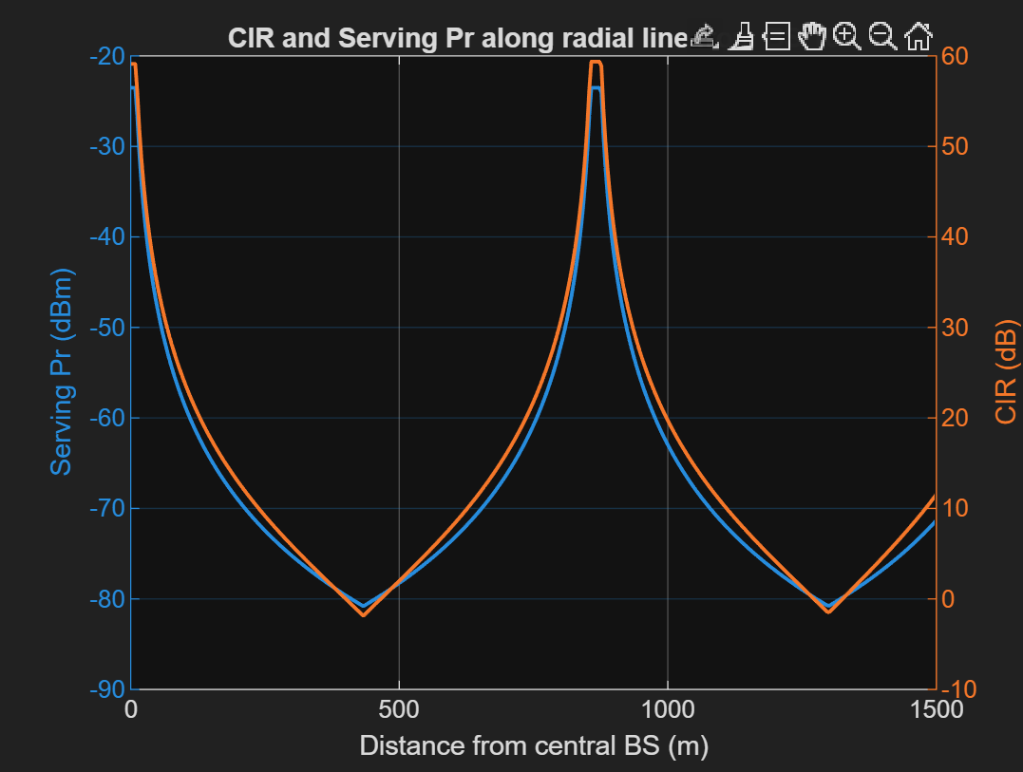

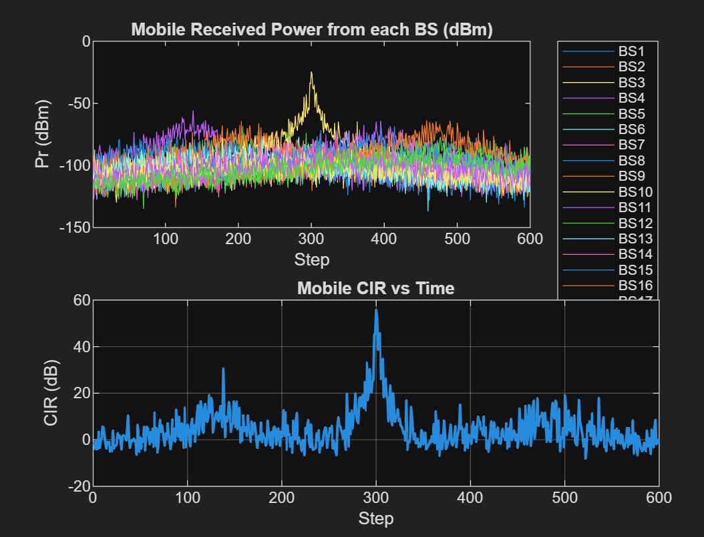
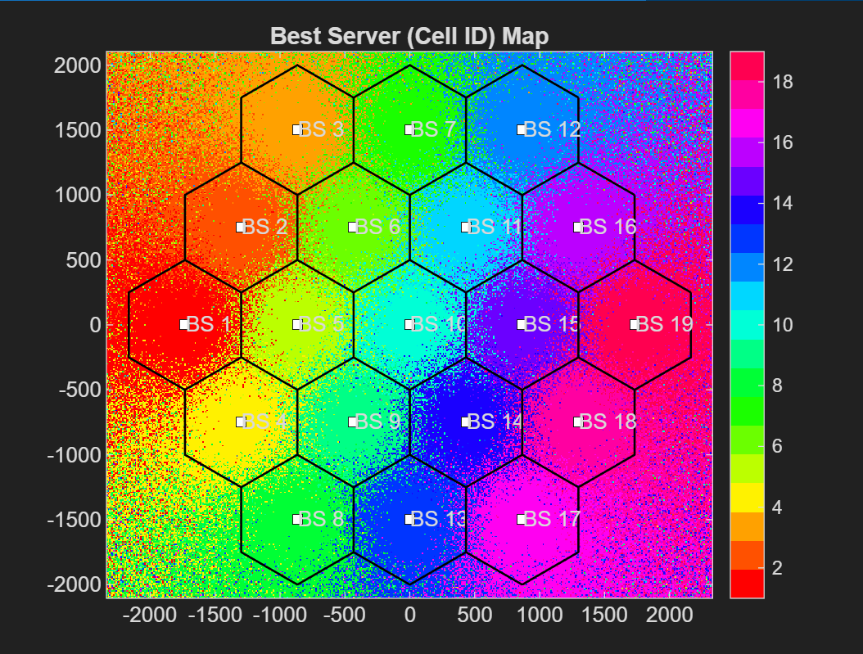

RESULTS:
The simulation results showed that each hexagonal cell provided clear coverage regions, and handoff points were accurately detected when the neighboring cell’s RSS surpassed the serving cell by the hysteresis margin. CIR analysis indicated high signal quality near cell centers, with noticeable degradation toward cell edges due to co-channel interference.

